Inheritance 2

A problem with our solution
We have a conflicting output...
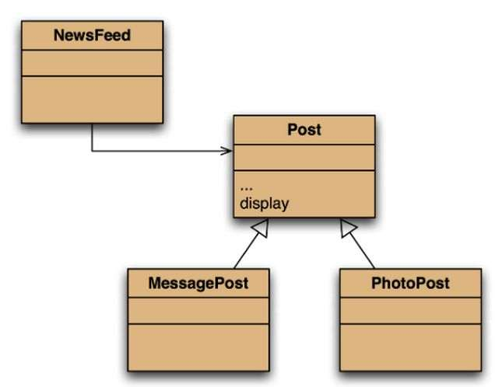
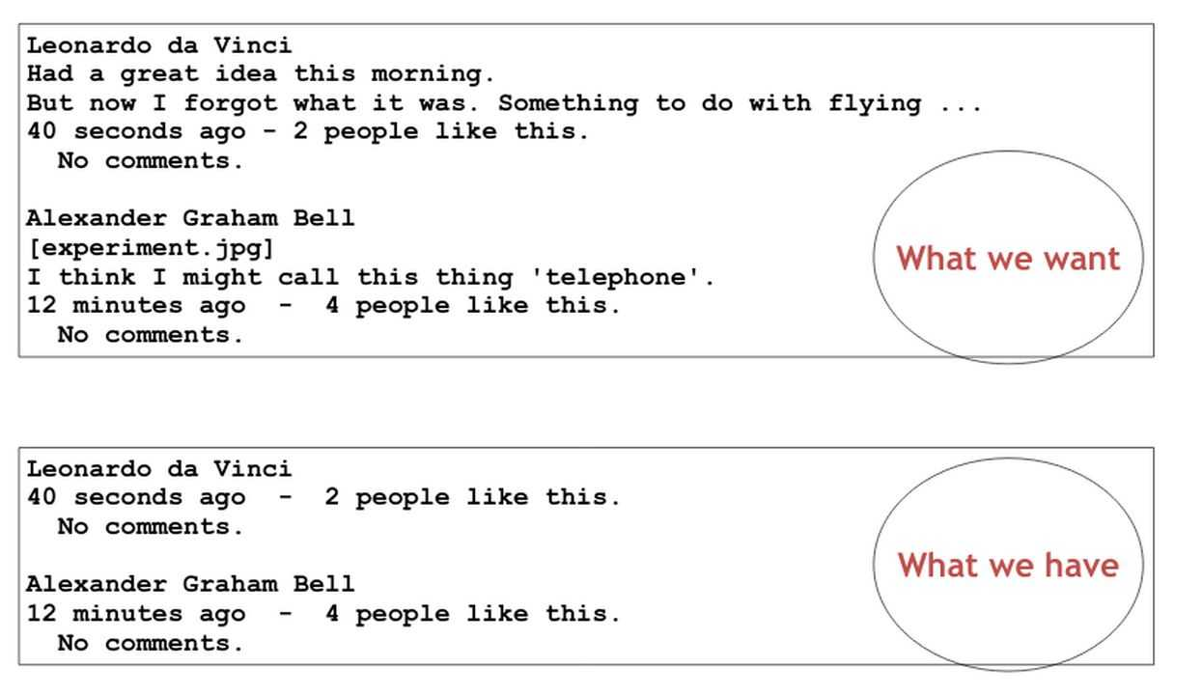

The display method in Post only prints the common fields.
This is because Inheritance is a one way street.
- A subclass inherits the superclass fields.
- The superclass knows nothing about its subclass’s fields.

Solution(?)
You could place the display method in the subclass…
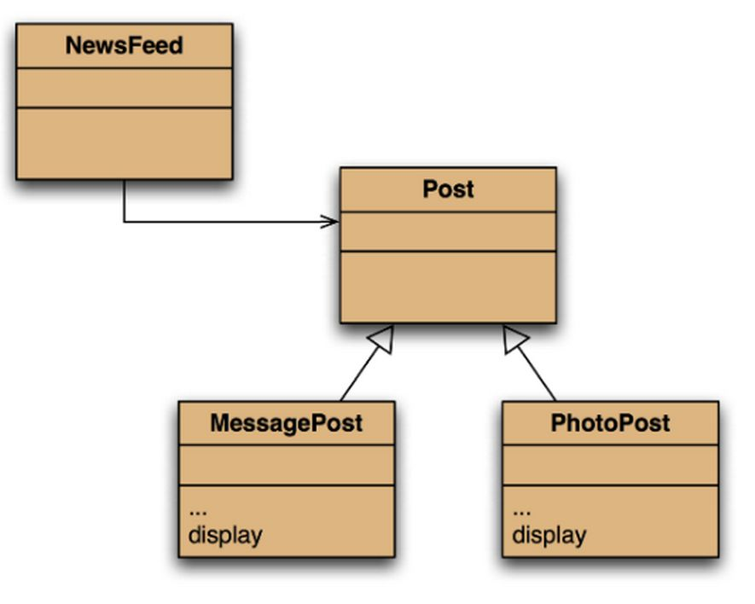
- Each subclass has its own version
- Post’s fields are private
- NewsFeed cannot find a display method in Post.
Therefore, it doesn’t solve our problem.

Static type and dynamic type
A more complex type hierarchy requires further concepts to describe it.
Some new terminology:
- Static type
- Dynamic type
- Method dispatch/lookup
Car c1 = new Car();
Vehicle v1 = new Car();
With inheritance, we have a situation where these types aren’t the same. Hence, why we have static and dynamic types.
- The declared type of a variable is its static type.
- The type of the object a variable refers to is its dynamic type.
- The compiler’s job is to check for static-type violations.
for(Post post: posts) {
post.display(); // compile time error
}

Method overriding
- Superclass and subclass define methods with the same signature.
- Each has access to the fields of its class.
- Superclass satisfies static type check.
- Subclass method is called at runtime – it overrides the superclass version.
- What becomes of the superclass version?
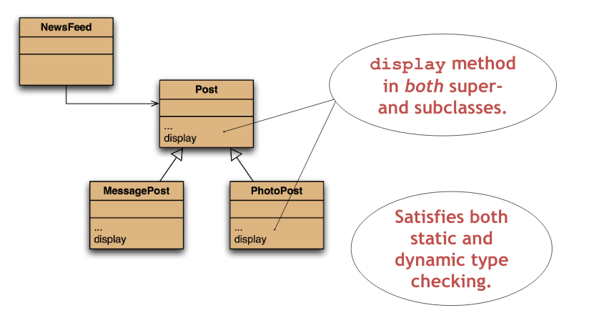

Dynamic method Dispatch
What happens if we have this situation and we call a method on our post variable?
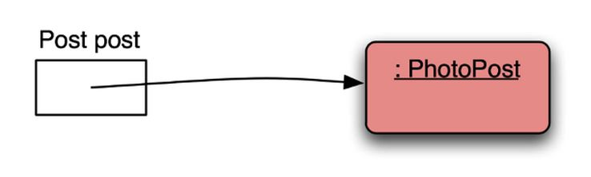

In a situation without inheritance...
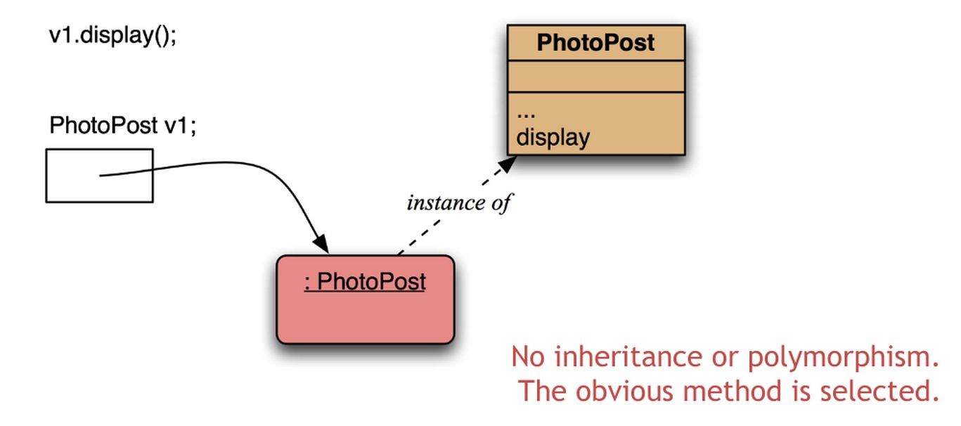

- Access the variable object
- From the object access the class
- From the class access the method
In a situation with inheritance…
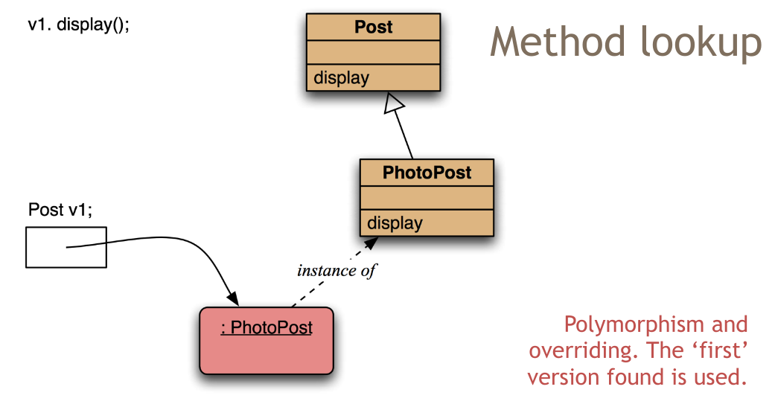
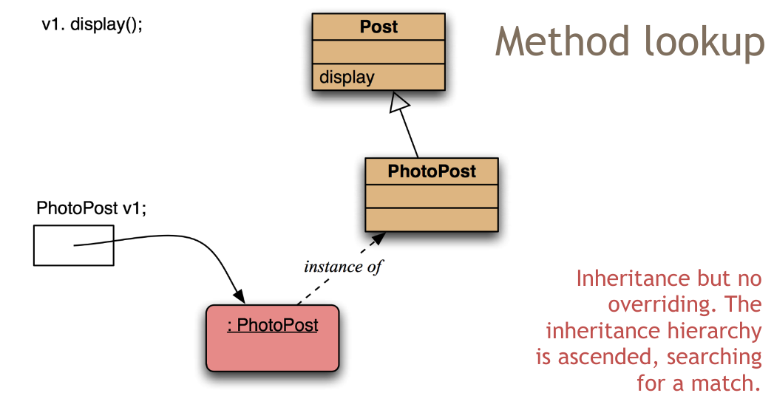

- Access the variable object
- From the object access the class
- From the class access the method
- If the method isn’t in the class, it then goes up the hierarchy to the superclass.

Calling overriden methods
Overriden methods are hidden, but we often still want to be able to call them.
- An overriden method can be called from the method that overrides it.
  - super.method(...)
  - Compare with the use of super in constructors.
    - They don’t need to be called first
public void display()
{
super.display();
System.out.println(" [" + filename +"]");
System.out.println(" " + caption);
}

Method polymorphism
We have been discussing polymorphic method dispatch.
- A polymorphic variable can store objects of varying types.
- Method calls are polymorphic.
  - The actual method called depends on the dynamic object type.

The instanceof operator
- Used to determine the dynamic type.
- Identifies “lost” type information
- In general, it is possible and better to avoid doing this. Is there a better, more extendable way to write your code?
- Usually precedes assignment with a cast to the dynamic type:
if (post instanceof MessagePost) {
MessagePost msg = (MessagePost) post;
[…]
}

Object and tostring

The object class’s methods
- Methods in Object are inherited by all classes.
- Any of these may be overridden.
- The toString method is commonly overriden:
  - public String toString()
  - Returns a string representation of the object.
Every method in the object class is available to all classes in Java. It is useful to look at what methods are actually in the object class.

Overriding tostring In post
public String toString()
{
String text = username + “\n” + timeString(timestamp);
if (likes > 0) {
text += “ - “ + likes + “people like this.\n”;
}
else {
text += “\n”;
}
if(comments.isEmpty()) {
return text + “No comments. \n”;
}
else {
return text + “ “ + comments.size() +
“comment (s). Click here to view.\n”;
}
}
This creates the string and returns the value rather than printing it out to terminal.
It is better to let the top level class decide how the value is printed.
Calls to println with just an object automatically results in toString being called:
System.out.println(post);

Stringbuilder
- Consider using StringBuilder as an alternative to concatenation:
StringBuilder builder = new StringBuilder();
builder.append(username);
builder.append(‘\n’);
builder.append(timeString(timestamp));
…
return builder.toString();

Protected access
Private access in the superclass may be too restrictive for a subclass.
- The closer inheritance relationship is supported by protected access.
- Protected access is more restricted than public access.
- We still recommend keeping fields private.
  - Define protected accessors and mutators.
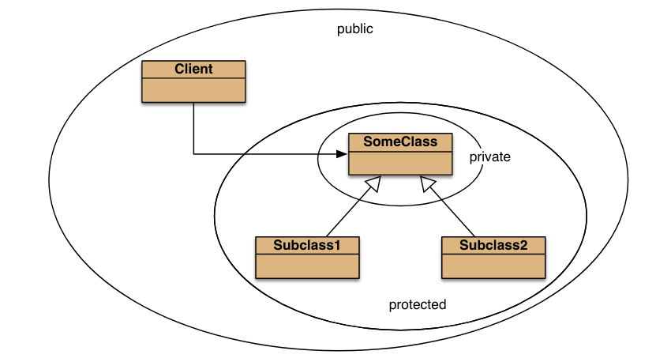
z

